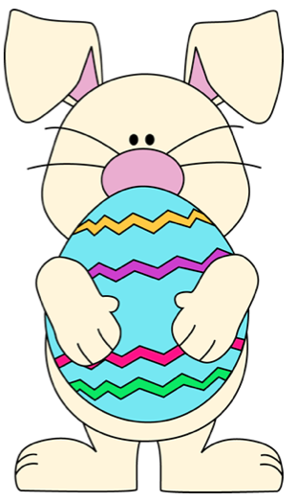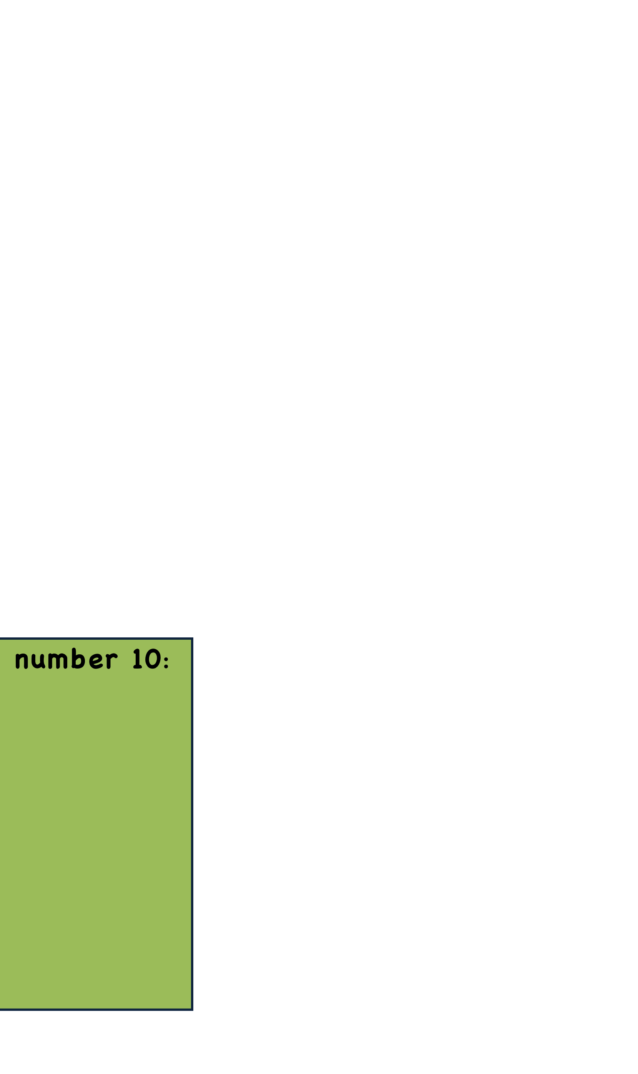

Cerney House Garden Easter Egg Trail

Lets get Cracking!

Clue number 3:

Find Getrude. What

bird is she? She can lay a golden egg!

_ _ _ _ _ E

**Across the garden there are things to spot. Can you find the objects?**

**Look for the 11 letters they are near the objects. The letters will make a phrase.**

**Complete all the words and spell out the phrase…**

**The reward for all you hard work is finding the Easter Bunny’ egg basket… he has hidden the chocolate eggs and goodies in there**

**Find Cedric. We have special Roman ones like this in the garden?**

**What is he?**

_ _ A _ _

**Clue number 4:**

**You could use this to tell the time if you had no watch**

**S _ _ _ _ _ _**

Clue number 1:

An exotic fruit.

You will find this on a Hawaiian Pizza

_ _ _ _ _ P _ _ _

Clue number 2:

\J]

Lets get Cracking!

**Can you find this large male chicken. He loves to wake you up in the morning…he is a bit noisy them**

_ _ _ _ R _ _

Clue number 7:

Clue number 6:

**This is another word for a giant mushroom. Fairies live under them**

T _ _ _ _ _ _ _ _

**Can you find a pair of these? They are boxing each other.**

**H_ _ _ _**

Clue number 5:

Clue number 8:

**We are looking for a bird whose has beautiful blue feathers.**

**P _ _ _ _ _ _**

**You have reached the end.**

**Use you letters to spell some words**

**You have been amazing. Go into the Bothy and the Easter Bunny secret stash awaits you……..**

Clue Number 11:

**This is the final clue. You are getting near the eggs…..**

**We must go to the tearoom**

**What is the special name for the tearoom**

**_ _ _ _ Y**

_

Clue number 10:

You are looking for something lying on is side. It should be standing tall. It is fun to climb

_ _ _ E

Clue number 9:

This is the seed of an oak tree. From these might oaks grow.

Can you find the seeds

A _ _ _ _

+

=

For You to Colour In

- sodales.

Etiam eu ipsum. Donec ac arcu.

Lorem ipsum dolor sit amet, consectetuer adipiscing elit. Vivamus semper sodales lorem. Quisque venenatis vehicula lectus. Donec a odio eu eros lobortis vehicula.